Mini project

CURRENCY CONVERTOR

**Introduction**

**Python** is a very versatile programming language. Python is being used in almost each mainstream technology and one can develop literally any application with it. Let’s see a Python program to convert the currency of one country to that of another country. To use this service, one must need the API key, which can be get from here. We will use fixer API to get the live conversion rates and convert the corresponding amount.

**What is a CURRENCY CONVERTOR?**

Currency conversion is the process of changing one currency into the currency of another country. For example, changing Australian dollars (AUD) into US Dollars (USD). Currencies are converted using an exchange rate. This rate is the relative price of two currencies.

Source code:

pip install forex-python

from forex_python.converter import CurrencyRates

def currency_converter(amount, from_currency, to_currency):

    c = CurrencyRates()

    result = c.convert(from_currency, to_currency, amount)

    return result

# Example usage

amount = float(input("Enter the amount: "))

from_currency = input("Convert from (3-letter currency code): ").upper()

to_currency = input("Convert to (3-letter currency code): ").upper()

converted_amount = currency_converter(amount, from_currency, to_currency)

print(f"{amount} {from_currency} is equal to {converted_amount} {to_currency}")

**output:**

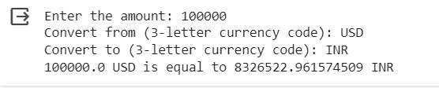

The MINI PROJECT “ CURRENCY CONVERTOR”, submitted by PAMANJI VISALAKSHI.

LINK:

(https://colab.research.google.com/drive/1LmF4QS89Sk4Y5ASaOk1130QzDKH6p6Kw#scrollTo=EeQ3fu-hMJ71)